1. Download and install mongodb community server
2. Check version of mongodb
   1. Open cmd and type >mongod --version

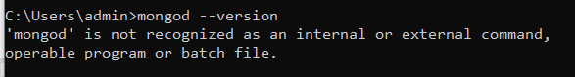

If you get like this then env variables are not set for mongodb. So lets set

1 – get mongodb installation path - C:\Program Files\MongoDB\Server\7.0\bin

2 – copy path and open env variable and add it to the system variable

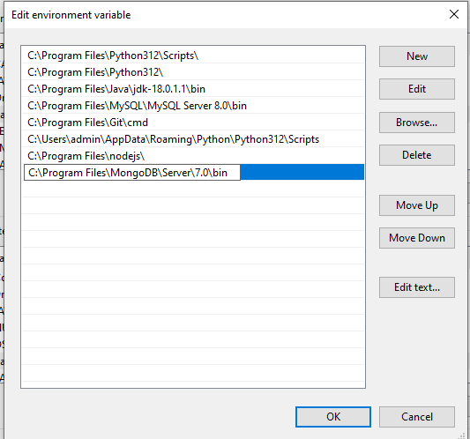

3 – open new cmd and type >mongod --version

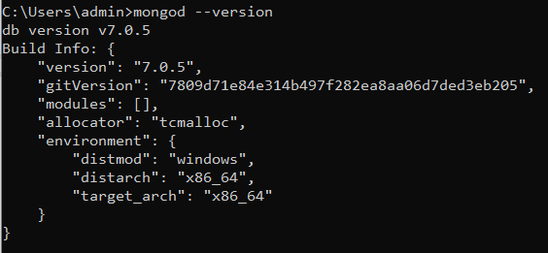

* 1. Close all cmds

1. Create folder to store database and logs files. Ex
   1. I have created mongoDB folder, in that folder, I have created 2 folders – data and logs

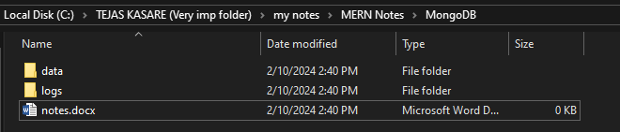

1. Open new cmd and connect with our newly created data and logs folder



DO NOT CLOSE THIS CMD

1. Running some mongodb commands on vs code
   1. Open VS code
   2. Add mongodb extension in vs code

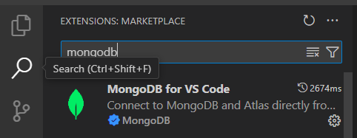

* 1. After adding above extension you will leaf icon on left side
  2. Click on add connection

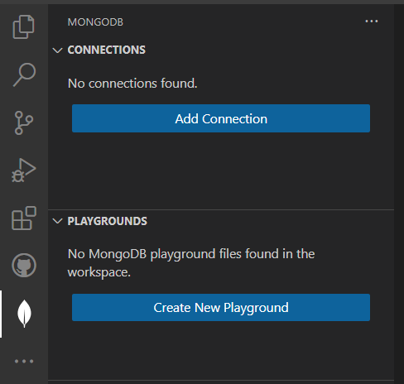

* 1. Add mongodb server url and connect

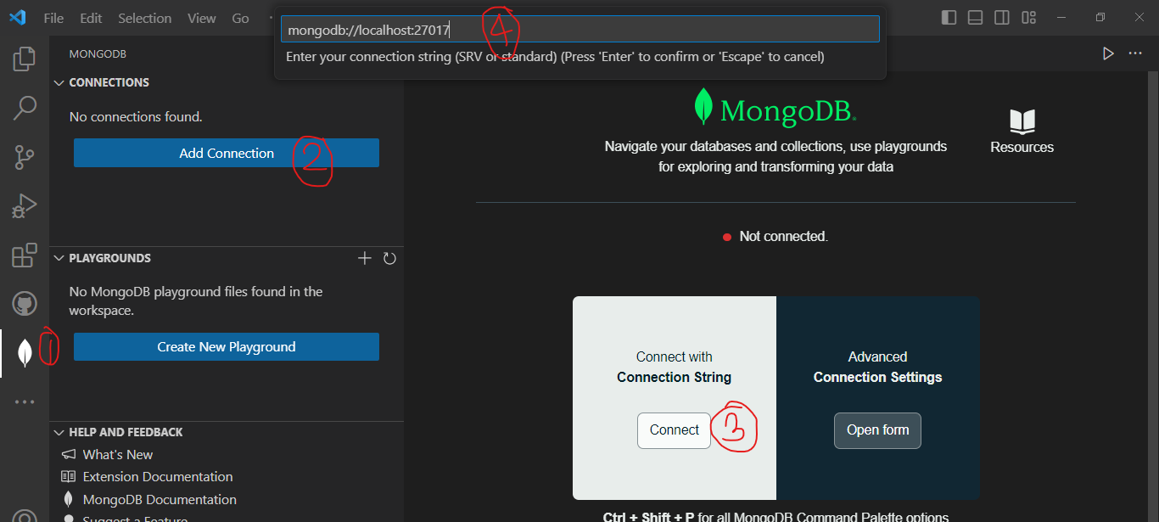

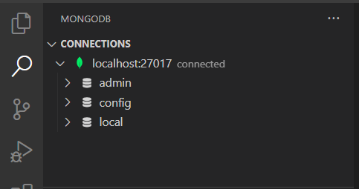

* 1. Now lets start coding

1. Running mongodb commands on vs code
   1. Click on create playground
   2. Remove existing code and add following

//creating database and table(collection)

//run below 2 commands at a time

//use('amazon');

//db.createCollection('products');

//----------------------------------------------------

//deleting database and collection

//use('dummy_db');

//db.createCollection('dummy_collection');

//dropping collection

//db.dummy_collection.drop()

//deropping databse

//db.dropDatabase()

//-------------------------------------------------------

//to get current database

//db; //test is default database given by mongodb

//use is used to switch database

use('amazon');

//getting name of collections/table from selected database

//db.getCollectionNames();

//getting list of all databases;

//db.getMongo().getDBs();

//insert 1 record into products

// db.products.insertOne(

//    {name:'iphone',price:200,quantity:5,colors:['red','black'],dimension:{w:10,h:20,unit:'cm'}},

// )

//insert mulitple record into products

//  db.products.insertMany(

//    [

//       {name:'tv',price:350,quantity:10,colors:['black','red'],dimension:{w:45,h:30,unit:'in'}},

//       {name:'book',price:150,quantity:15,colors:['red','black','blue'],dimension:{w:10,h:15,unit:'in'}},

//       {name:'notebook',price:100,quantity:5,colors:['yellow','black'],dimension:{w:10,h:15,unit:'cm'}},

//       {name:'pen',price:50,quantity:100,colors:['blue','green'],dimension:{w:5,h:10,unit:'cm'}}

//    ]

// )

//select * from products;

//db.products.find()

//select * from products where quantity = 5;

// db.products.find(

//    {quantity:5}

// )

//select * from products where quantity = 5 limit 1;

// db.products.findOne(

//    {quantity:5}

// )

//inserting one record without all fields

// db.products.insertOne(

//    {name:'chair',quantity:8}

// )

//inserting one record with diff fields

// db.products.insertOne(

//    {gender:'m',city:'pune'}

// )

// ---------------------  UPDATE  ------------------------------------------------------

//update products set quantity=10 where name=chair

//db.products.updateOne({name:'chair'},{ $set:{quantity:10}})

//db.products.find()

//update products set quantity=10,price=250 where name=chair

//here we can add last modified date for future use

//db.products.updateOne(

//    {name:'chair'},

//    { $set:{quantity:10,price:250}, $currentDate:{lastModifiedDate:true}}

// )

//db.products.find()

// ----------------------------------- DELETE --------------------------------

//delete from products where gender = m

// db.products.deleteOne(

//    {gender:'m'}

// )

//db.products.find()

//deleting based in id

//65c7592b51069dbde24873c2 copy the _id of chair

// db.products.deleteOne(

//    {  _id : ObjectId('65c7592b51069dbde24873c2')}

// )

//db.products.find()